What Is a Tragedy?

A tragedy is a very, very, very sad and terrible event. I may first learn about a tragedy when I watch television. This is because tragedies almost always happen someplace else.
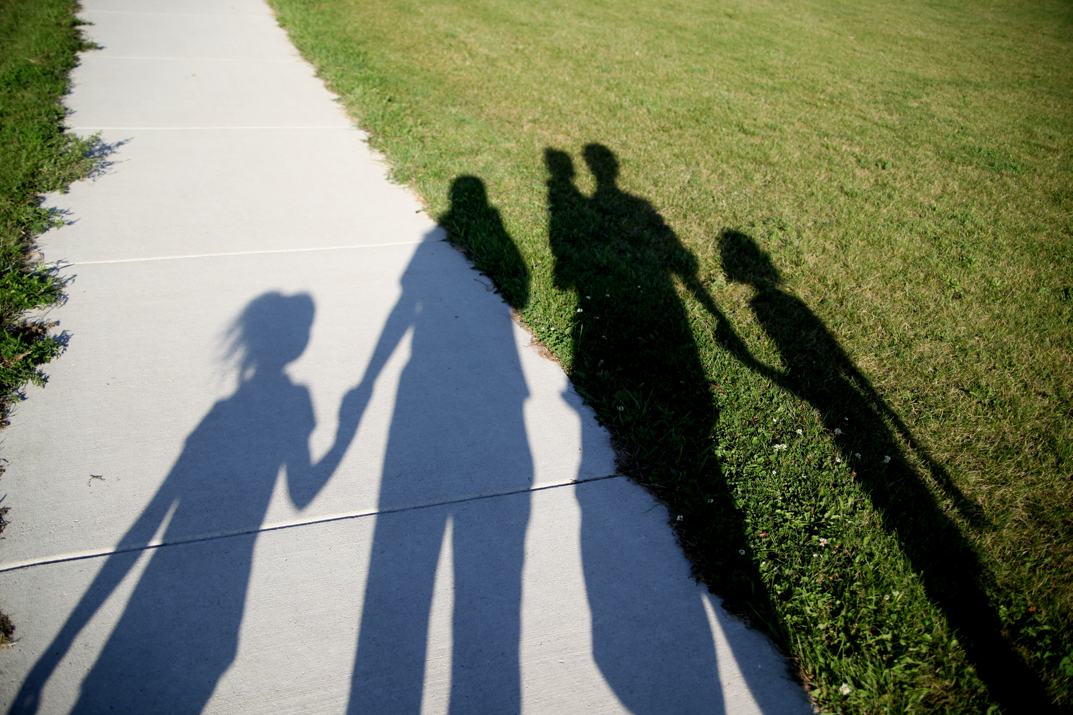

Tragedies have survivors. Survivors are people who are alive after a tragedy. They have lost something very important to them, like their home.

© Carol Gray, 2013. Exclusive and restricted permission is hereby granted to print the Stories and activities in The Social Story Sampler for use with an individual or small group in a home, educational or clinical setting. May not be copied or used in presentation, or for financial gain. All other rights and restrictions apply.

Or a survivor may know or love someone who has died in the tragedy. A tragedy is a very sad time, especially for the survivors.

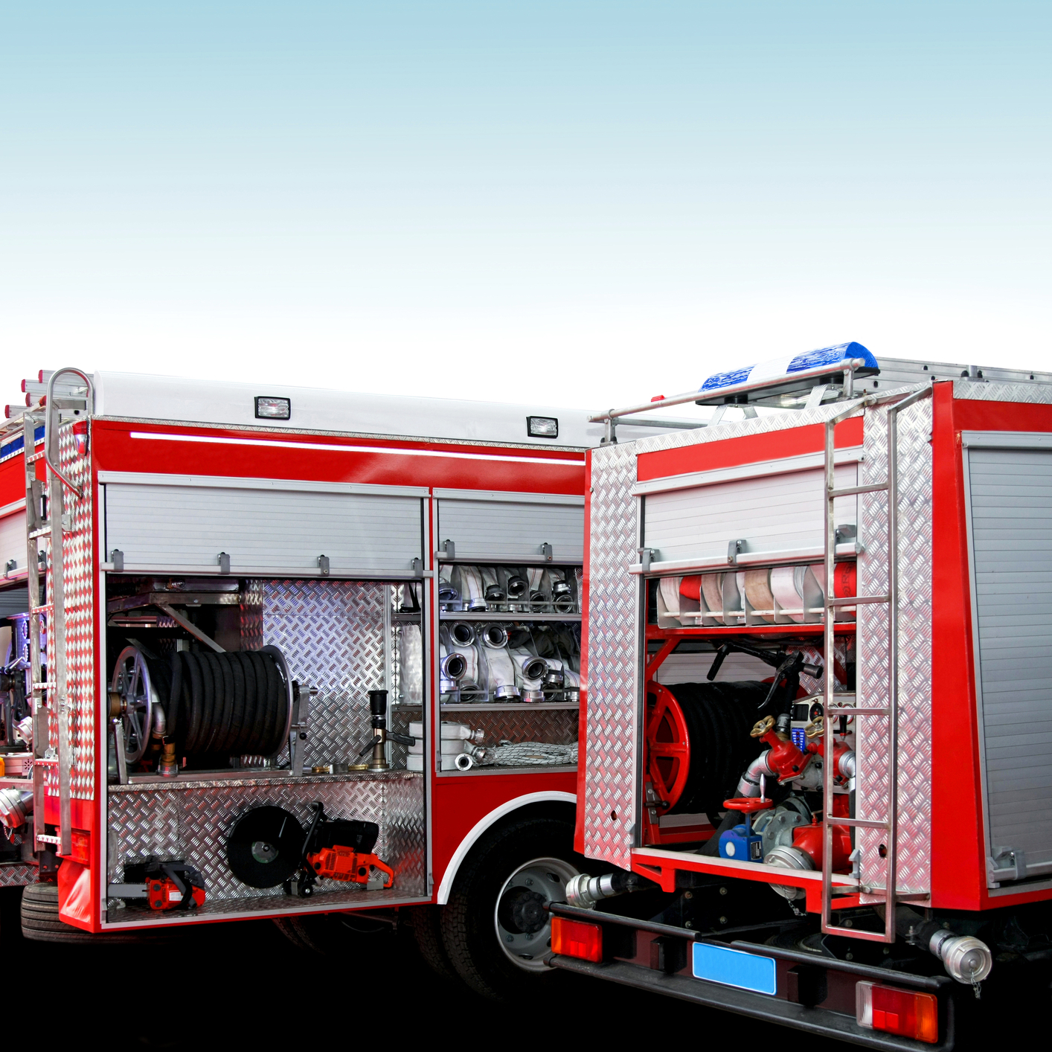

After a tragedy, the police and rescue people arrive. They help the survivors.

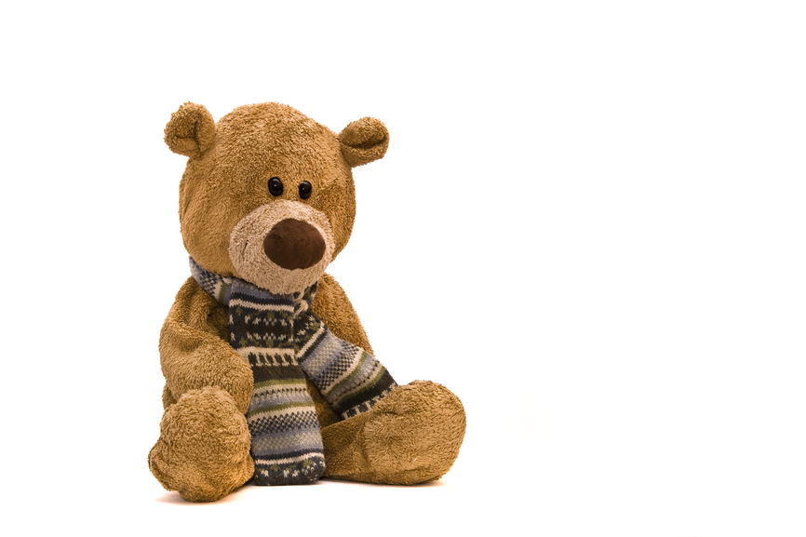
Sometimes, many people bring flowers or teddy bears that mean, “We feel very sad, too.” They all leave them in a special place near where the tragedy happened. Sharing sad feelings helps survivors, and other people, too.

After a tragedy, there are many hard questions. People study and work together to find the answers, and new ways to keep people safe.
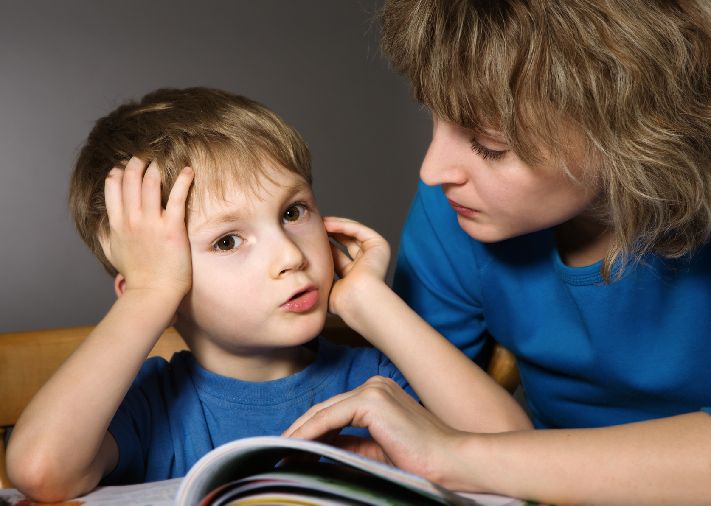
I may have questions too. Parents, teachers, or counselors can help. If there are really hard questions, we can work on the answers together.

