**Who is on my school team and what they know about me?**

My name is Ben. I am seven years old. I'm learning about who is on my school team.

A team is a group of people who work together. A school team is a group of teachers that work together to help children learn. They help children get along with other children too.

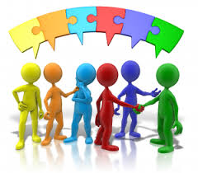

My school team is Mrs Smith, Mrs Wright, Mrs Donaldson, Mrs Andrews, Mrs Carson, Mr Buning, and my class TAs.

**Ben's school team**

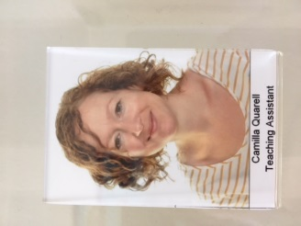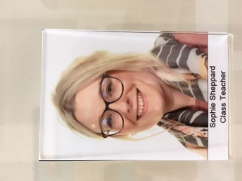

My school team knows about me.

My school team knows that I like Pokémon

My school team knows that I like playing games on the laptop.

My school team knows that I like swimming.

My school team knows that I like dinosaurs.

My school team knows that I have two safe spaces in school that I may use when I need to take a break.

My school team knows that I don’t like people bumping into me.

When I need help at school I may ask one of my school team. My school team will be pleased to help me.

A school team is a group of teachers that work together to help children learn and to help children get along. I'm learning about who is on my school team.