**Who helps me in the classroom**

My name is Ben. I am 7 years old. I am in year 2 at school.

Children go to school to learn new things. Sometimes learning new things is easy and happens straight away. Sometimes children need help to understand and learn. Teachers help children to learn and to understand. Teachers know how to help children get along with other children too.



Usually my teachers are Mrs Smith and Mrs Wright.

*Photo of Mrs Turner to follow*

In Daffodil class, there are also teaching assistants. A teaching assistant can be called a TA for short.

A TAs job is to help children learn too. TAs often take small groups of children out of a class for a short time to help them with their work. Sometimes TAs change as they work with other schools. This is ok.

Usually, the TA's in my class are Mrs Johnson, Ms Davis, and (*name/photo of the other TA to follow).*

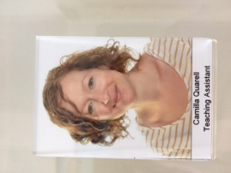 

Mrs Smith and Mrs Wright know about me and how to help me understand and learn. Mrs Smith and Mrs Wright know how to help me get along with other children too.

The TAs know about me. The TAs know how to help me understand and learn. The TAs know how to help me get along with other children too.

When I need help, I may ask my teacher or the TA. My teacher or TA will be pleased to help me.

I'll be pleased to help Ben

I'll be pleased to help Ben

I'll be pleased to help Ben

  

I am learning about help in the classroom.