My safe place at school

My name is Ben. I am 7 years old. I go to school.

A safe place is a place someone can use when they need to take a break if they are close to a number 5 feeling.

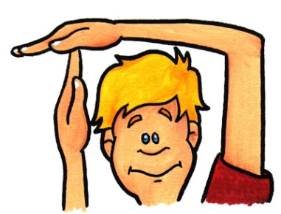

Many people use a safe place to take a break to calm down until they feel just right again.

In my school, I have 2 two safe places.

There is a safe place in Daffodil class.

There is a safe place in Mrs. Green’s and Mr. Thompson’s office.

*PHOTOS OF OFFICE AND CLASS PLACES*

I may go to one of these safe places when I feel I need to take a break.

When I feel just right again, I will try and re-join my class. My teachers will be pleased when I try and re-join the class.



A safe place is a place someone can use when they need to take a break if they are close to a number 5 feeling.