A Social Story™ for the Rest of Us
Carol Gray, with Dr. Siobhan Timmins

My sincere appreciation to Dr. Siobhan Timmins for her expert and insightful feedback on several drafts of this Story. I am blessed to have her as a colleague and friend.

© Carol Gray, 2019. Exclusive permission is granted to distribute or use in presentation, only in its entirety and accompanied by the following complete referencing with each use:
Gray, C. (October 1, 2019). A Social Story™ for the rest of us. Retrieved online https://carolgraysocialstories.com/carols-club/clubhouse/
I am a typical adult. I have a son, daughter, student, or client who is diagnosed with autism. “Autism, or autism spectrum disorder (ASD), refers to a broad range of conditions characterized by challenges with social skills, repetitive behaviors, speech and nonverbal communication” (Autism Speaks).
Dr. Stephen Shore, a professor at Adelphi University and person with autism has said that,
“If you’ve met one person with autism, you’ve met one person with autism” (Shore, date unknown). This means that I will need to learn about autism over and over again, as long as I keep meeting people with autism. This is okay.

Every person is the result of a combination of genes and life experiences. Together, they express themselves in a one-time-only physical appearance and a never-to-be-repeated constellation of strengths, weaknesses, temperament, personality, and talent.

Despite that, most typical people perceive and respond to sights, sounds, and social factors within a similar or “typical” range. As they grow, they begin making assumptions about what other people know, think, feel, or believe and pride themselves in how often they are right. I will try to abandon thinking I am right about this sort of thing all the time.

Just like everyone else, a child, adolescent, or adult with autism is unique. In a way, having autism is like being unique twice - once as a person and again because of autism. With autism, the perception and interpretation of sights, sounds, and social factors are atypical at times. When I’m with a person with autism, I will try to recognize all that we have in common, respect the differences, and respond accordingly.

Adults often attribute typical intent or motivation to explain the atypical responses of a child with autism. They are likely to be in error. Autism is more at ease with people who are socially curious, who take time to gather information about how things look, sound, and feel to another person.

Social curiosity comes naturally to some people; others learn it with practice. A few people are “socially decided” and do not entertain the possibility of human experiences outside of their own. I will try to be socially curious.
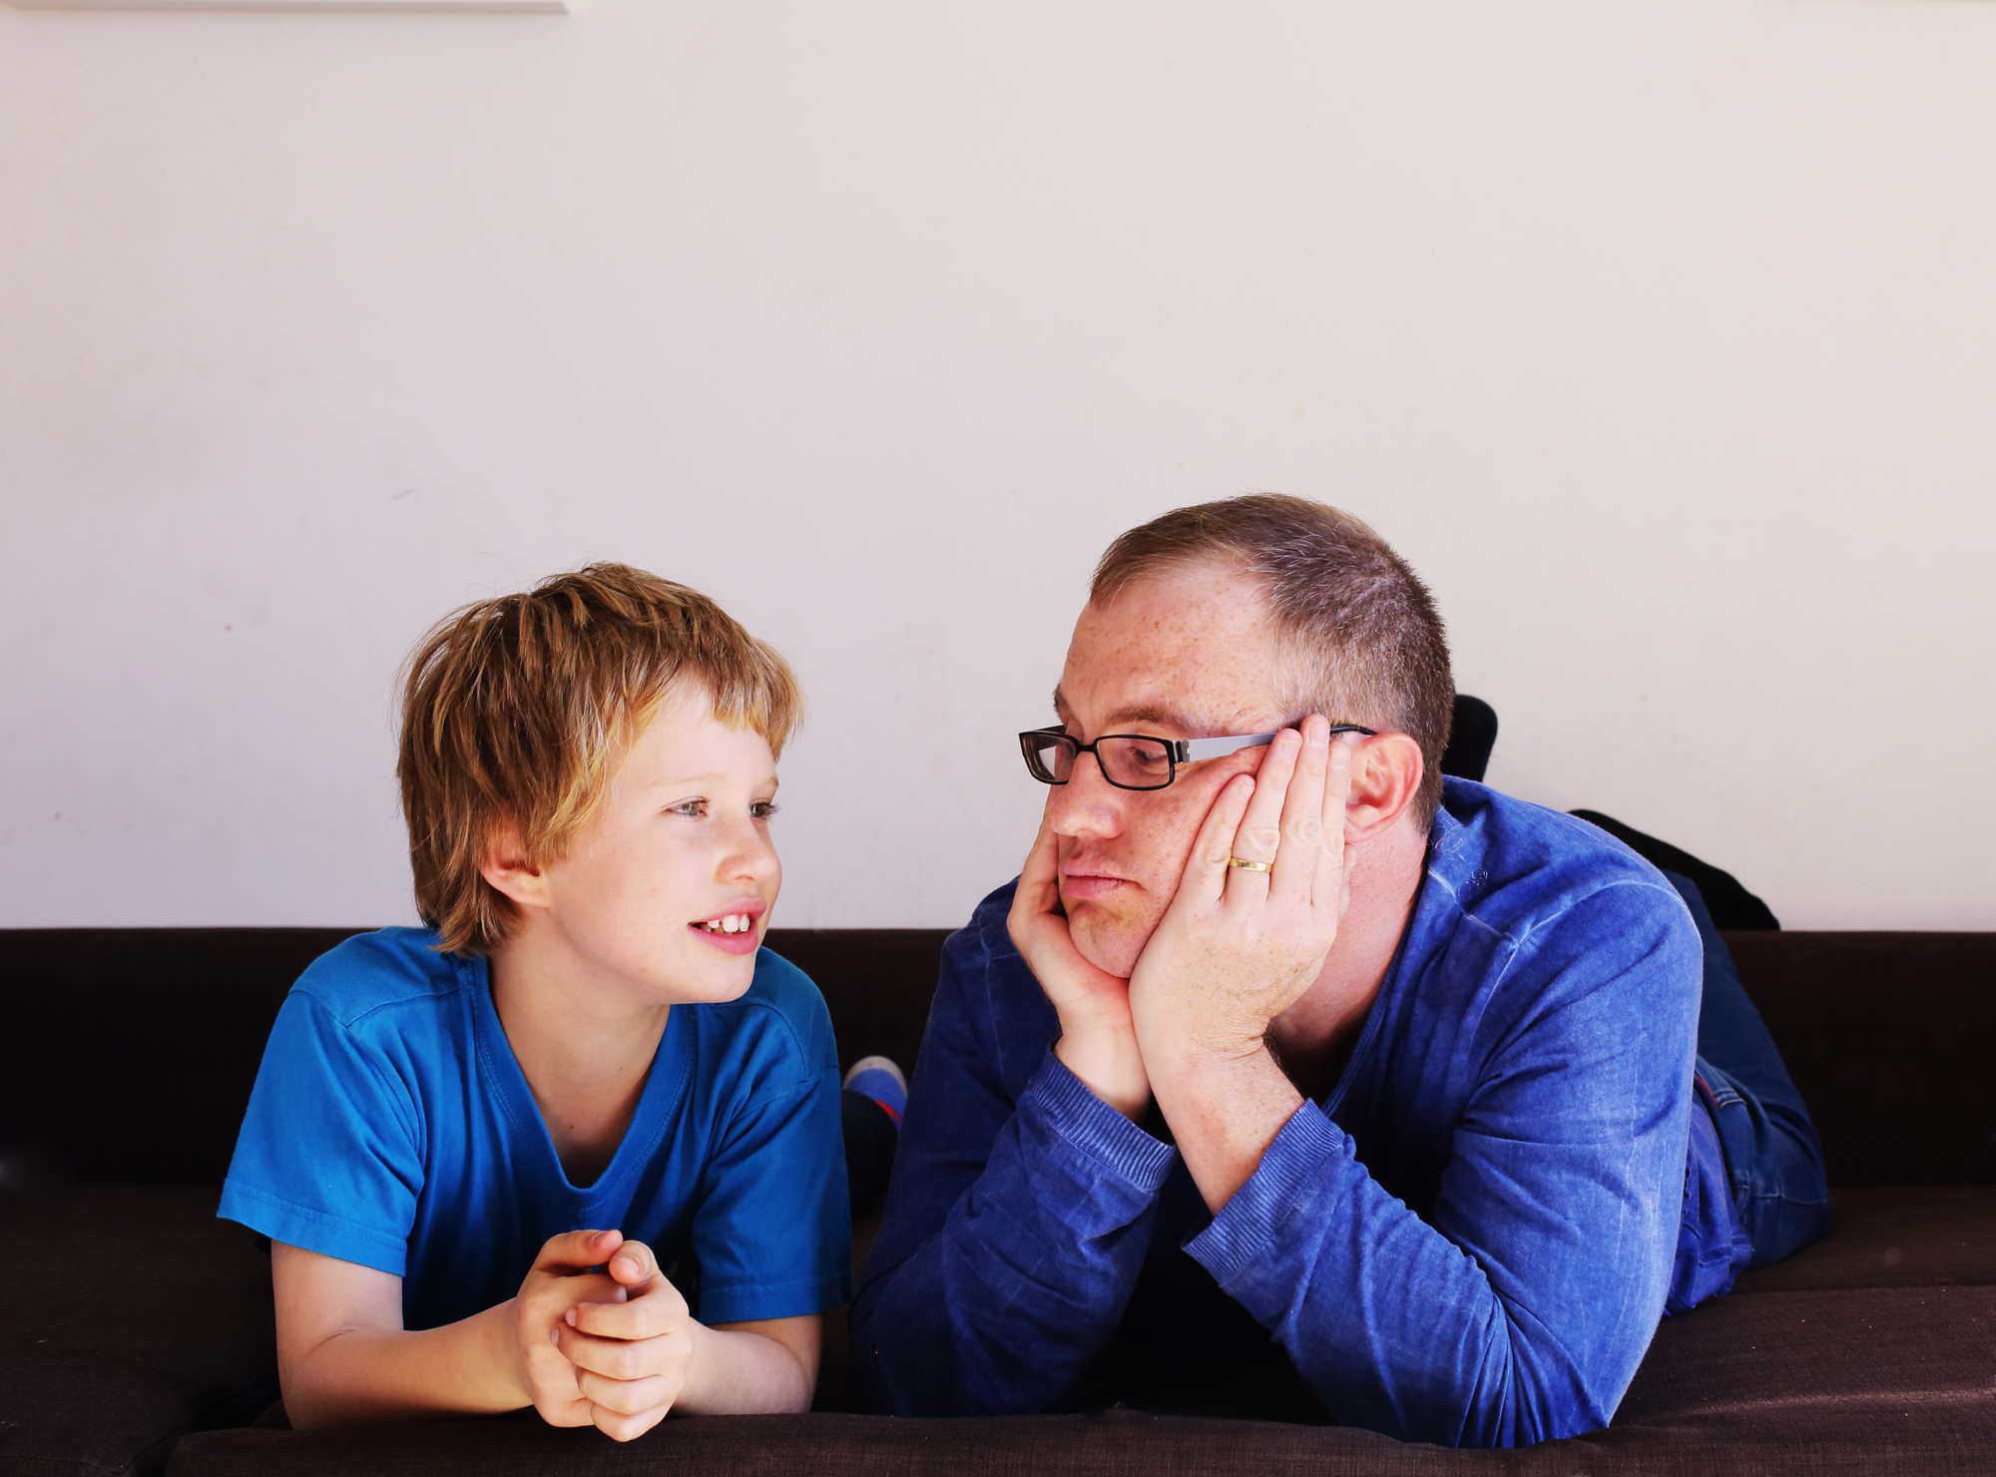

A sense of humor is essential when working with a child, adolescent, or adult with autism. Humor renews energy and resets focus, and sustains the Socially Curious when they are confused.

It is theorized that curious people make fewer social errors and are more likely to recognize and fix the mistakes that they do make. I will try to process my mistakes with creativity and a forgiving sense of humor.

To successfully raise, teach, or consult on behalf of an individual with autism is to ensure equal access to information. People with autism may be misled by anything animate or inanimate; from nonverbal social factors to a single word in conversation or a billboard along the highway. I will try to watch out for this and be ready to describe or explain things.

Whether I am a parent or teacher, therapist or physician, I am part of an educational team. The best educational teams recognize that:


- Feeling safe facilitates learning.
- Understanding what’s next reduces anxiety.
- Personalized structure builds predictability, supports effort, and builds confidence.
- Successful communication occurs when meaning is unaltered as it travels from sender to recipient and back again.
- Autism can alter intended meaning.
- Using autism-friendly phrasing and formats helps to ensure that intended messages remain intact.
- Being social is often fun and best taught that way.
- Social concepts make it possible for social skills to internalize, cross boundaries, and mix and match with little or no advance notice.
- Social concepts can be taught.

- People are usually employed doing something that they have done well all along.

- What adults say and do, and how they say and do it, matters. A lot.
I will try to be an effective member of an educational team.

I am ready to learn about autism repeatedly. Each person is unique. Autism is never the same twice, either. Social curiosity complements autism. Humor re-energizes patience and re-sets attention and focus. Children, adolescents, and adults with autism sometimes need educators to structure and ensure their equal access to information. Everything that I say and do on behalf of a person with autism has an impact. Positive and creative teaching fosters growth.
My name is ______________ and this my Social Story. I will try to keep it in a safe place, just in case I want to read it again sometime or share it with someone else.

References
Autism Speaks. What is autism? Retrieved online from Autism Speaks: https://www.autismspeaks.org/what-autism
Rosenfeld, J. (April 11, 2018, updated March 27, 2019). 11 scientific benefits of having a laugh. Retrieved online from Mental Floss: https://mentalfloss.com/article/539632/scientific-benefits-having-laugh
Shore, S. What is autism? Retrieved online from Autism Speaks: https://www.autismspeaks.org/what-autism

