Andrew Dressed as Goofy



This is a photo of Andrew. Andrew works in the Magic Kingdom at Disney World.



Andrew has many clothes. He likes to wear jeans. He wears jeans whenever he can.



Andrew wears jeans when he doesn’t have to go to work and he has a day off.



Andrew has dress-up clothes, too.





Andrew does not wear these clothes for his job at the Magic Kingdom. He wears a costume. A costume is clothes that make someone look like someone or something else.

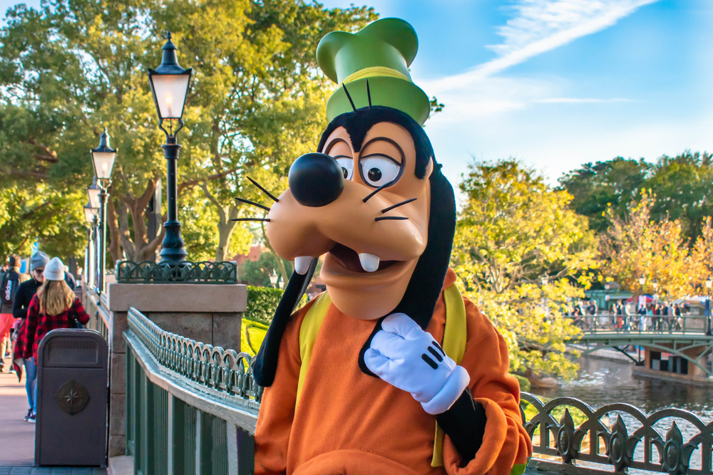

Andrew puts on clothes to make him look like Goofy. Then he goes to work. This is a photo of Andrew dressed as Goofy.

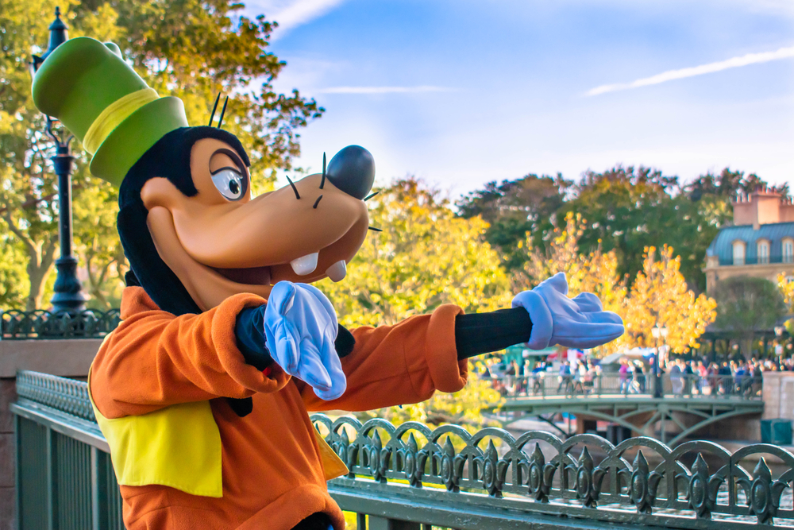

When we visit the Magic Kingdom at Disney, we may see Andrew at work, dressed as Goofy.